User Guide for ‘A Novel Secondary Poisoning Model for Pharmaceutical Bioaccumulation in Aquatic, Terrestrial, and Subterranean Food Webs’
Charlie J. E. Davey, Una Milovanović, Jiaqi Wang, A. Jan Hendriks, Ad M. J. Ragas

Introduction 2
Downloading the Excel version of the Model 3
Quick Overview 3
Input Data 7
Chemical Data 7
Aquatic Environmental Data 7
Terrestrial Environmental Data 7
Species Data 7
Timescale and Links 8
Experimental Sub-models 8
LFER Estimations 8
Biodegradation 8
Running the Model 8

Introduction
This document provides a brief user guide for the model developed by the authors in the publication titled "A Novel Secondary Poisoning Model for Pharmaceutical Bioaccumulation in Aquatic, Terrestrial, and Subterranean Food Webs”, otherwise referred to as the SPM.








The SPM was designed to estimate the whole-body steady-state concentrations of pharmaceuticals in an array of food chains. The food chains can involve any animal in the subterranean, terrestrial, and aquatic environments provided the relevant species information are provided to the model (Figure 1). The model can also estimate any combination of animals in a food chain, even if that food chain is unrealistic. While the SPM was designed for, and validated against, pharmaceuticals, any chemical can be used as an input into the SPM, provided the correct data are entered.
The SPM works by calculating kinetic parameters from basic input data about the chemical, environment, and species in the scenario. These kinetic parameters are compared to concentrations in either the environment (e.g. water), food, or inside the organism at each timestep to calculate the new concentration inside the organism (Figure 2). Since one organism might be another’s’ food, the food concentration will also change. These dynamics are what create the kinetic model, which might take some time to come to an equilibrium, or steady state.
Figure 1: Examples of subterranean/terrestrial (right panel) and aquatic (left panel) foodwebs

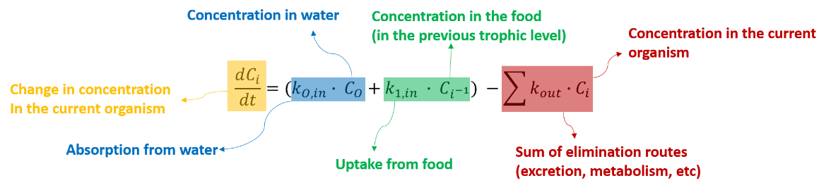
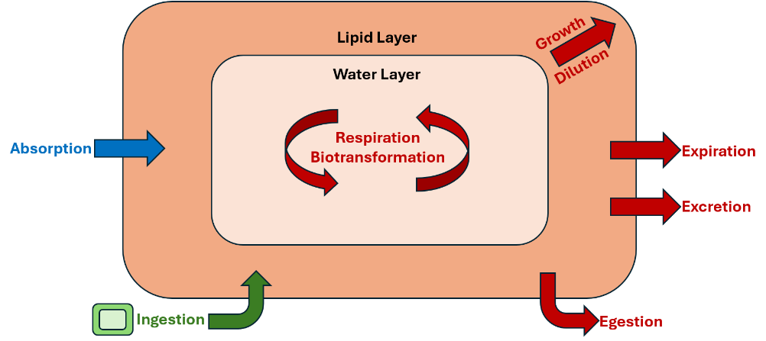
Figure 2: The overall model equation (Top) showing the three uptake and elimination routes, and a representation of an organism within the SPM (Bottom) with the corresponding uptake and elimination routes in the same colour.

Downloading the Excel version of the Model
The excel version of the model can be downloaded from either the GITHUB page, or along with the supplementary information of the study. Links to the GITHUB can also be found on the PREMIER website:
Source | Link
GITHUB | https://github.com/FunkNoodle/Secondary-Poisoning-Model
PREMIER Website
Publication

Quick Overview
The model is divided into a number of ‘blocks’ that are mostly used for calculating either the kinetic rate constants. These blocks are spread across 3 pages in the excel sheet, and all the equations for these blocks can be found in either the main text or the SI of the publication. There is also a graph, but we will come to that later. Here is a quick overview of the blocks and what they do:
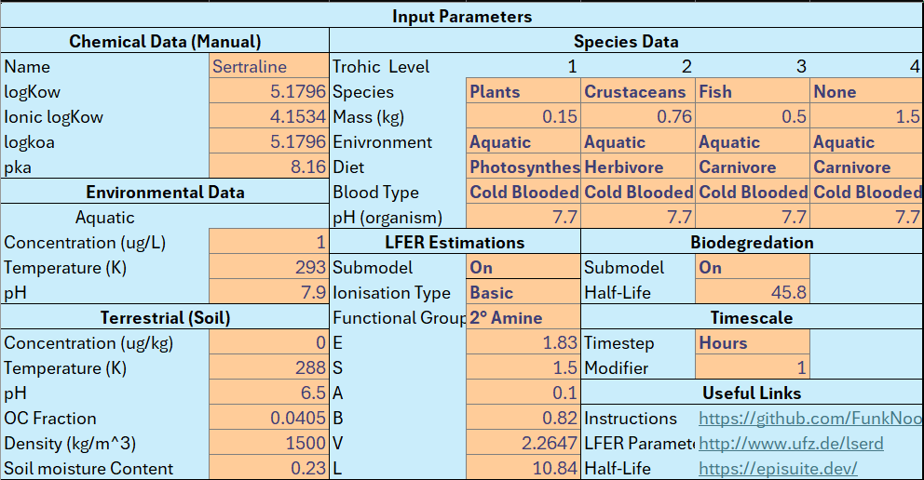
Figure 3: Input Parameters Block
This is the primary block the user will be interacting with. It allows the user to input all the data that is needed to run the model. It will be discussed in detail in the next section.
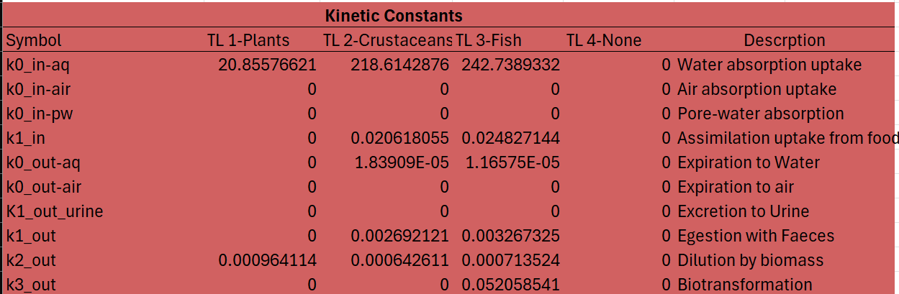
Figure 4: Kinetic Constants Block
These are the kinetic constants that are calculated in the calculations page, and correspond with the main model equation in the paper. There are a mixture of in and out pathways. It is important to note that some will return a value of zero in some circumstances. In this example, the food chain is all aquatic (see Figure 3), and therefore, things such as air uptake are turned off, and thus appear as a zero. The 4th trophic level also returns zeros since it has been set to “None”, which switches it off.
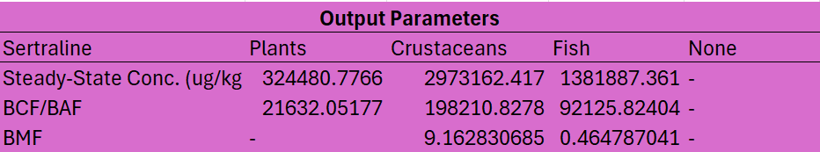
Figure 5: Output Parameters Block
The output parameters block offers some key information from the model. Namely the whole-body steady state concentration, the BCF or BAF (depending if the model is simulating food or not) and the BMF (Also depending on if there is food or not).
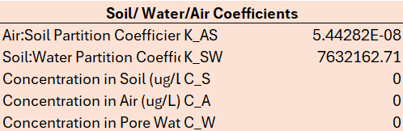
Figure 6: Soil/Water/Air Coefficients Block
This small block calculates some basic coefficients in preparation for the terrestrial block, which are to do with equilibriums between soil pore-water and air concentrations. Because the example food chain is aquatic, we have zeros for the concentrations here.
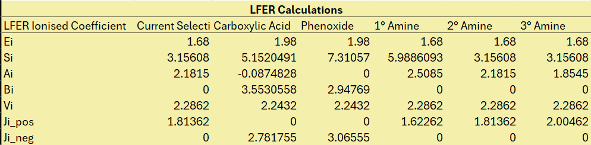
Figure 7: Linear Free Energy Relationship Calculations Block
The LFER Calculations are only needed if the LFER sub-model is turned on (see Experimental Sub-models for more). It plugs the LFER coefficients into the equations from the main paper, then looks up which one is correct for the compound in the input parameters based on its functional group.
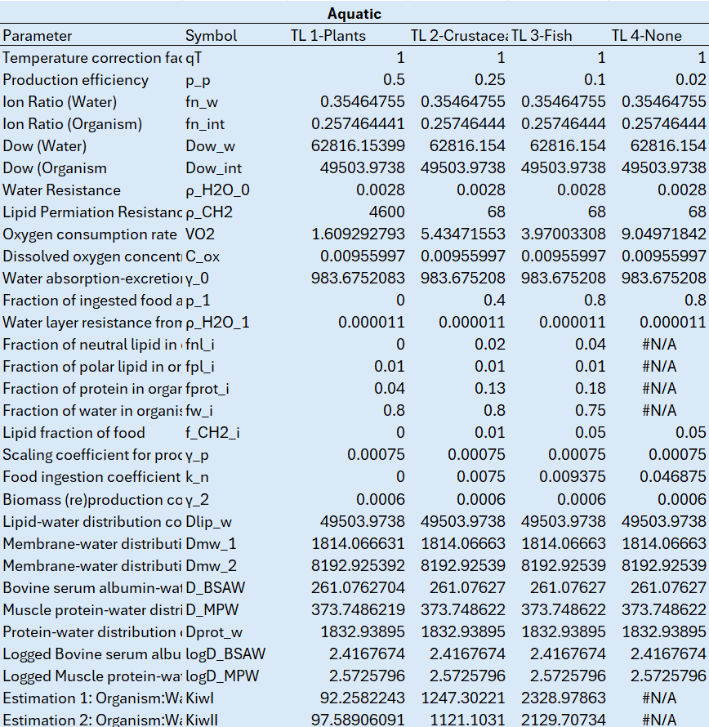
Figure 8: Aquatic Block
The aquatic block is the main calculation block of the model. It calculates all of the parameters needed to calculate the kinetic constants. Since the aquatic side of the model was made first, this block does most of the heavy lifting.
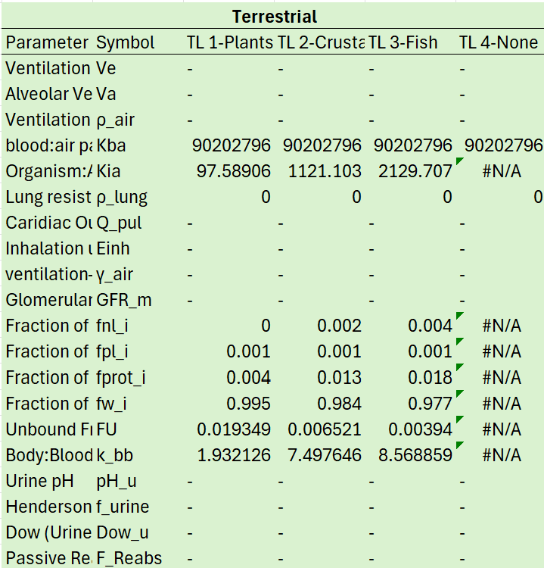
Figure 9: Terrestrial Block
The terrestrial block was added after the aquatic block, and performs additional calculations to allow for the kinetic constants relevant for the terrestrial and subterranean variants to be calculated.
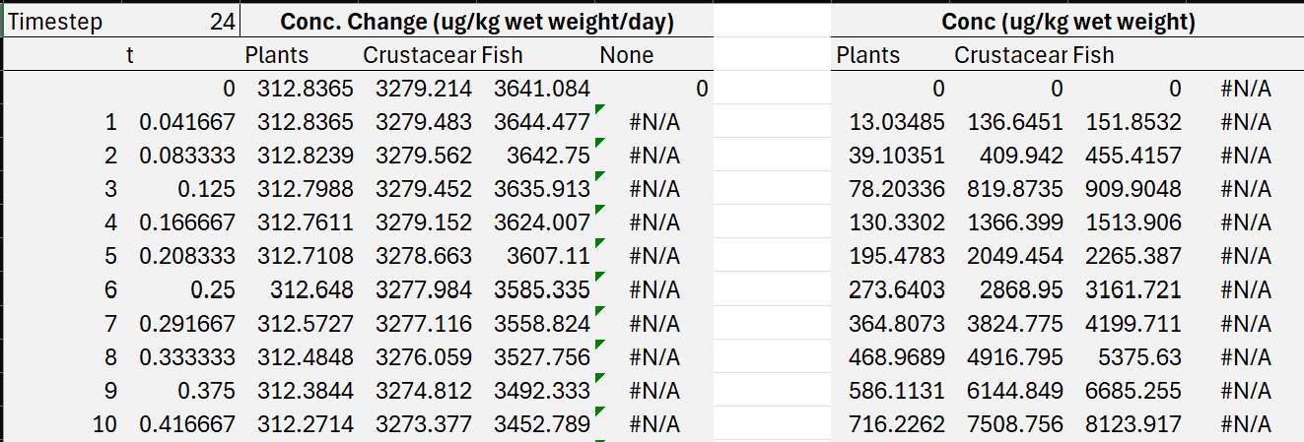
Figure 10: Concentration Change and Concentration Blocks
These blocks are used to run the kinetic model and make the graph seen on the input and output page. The first column is the timestep, which is how many steps the model is going to make. By default, there are 1000 timesteps, but this can be increased by as much as excel can handle. Validation was performed with 1 million timesteps, for example. The second column is the actual time (in days) as calculated by the number seen at the very top (in this case 24). This number is the modifier made from the timestep and modifier options in the input data (see timescale and links). In this case, the timestep was set to hours, and the modifier to 1, which gives us a value of 24 to divide each timestep by. This means that the actual timesteps are 1 hour denoted in days. The next four columns are the concentration changes happening at each timestep for each trophic level. These go down over time. The second block contains the actual concentrations in each tropic level. These go up over time.

Input Data
Within the input parameters block there are many sub-blocks for the user to enter data into. The orange cells indicate where the user can enter data, and the bold orange cells indicate a drop-down menu.

Chemical Data

Here, the user can enter the name, logKow, ionic LogKow, LogKoa, and pKa of the chemical. These data can be found in databases or calculated via online tools. Good sources include PubChem, CompTox, RDKit, and EPISuite.

Aquatic Environmental Data

Here, the user can enter the aquatic concentration, aquatic temperature, and aquatic pH.

Terrestrial Environmental Data

Here, the user can enter data for the terrestrial and subterranean model variants to use. The main difference between this block and the aquatic block is that it requires the Organic Carbon (OC) fraction, soil density, and soil moisture content.

Species Data

The species data sub-block is an important block. The user can enter data for up to four trophic levels, however not all four need to be used, as is the case here. The species line contains the species types in drop-down menus that are compatible with the model (Algae, Plants, Worms, Molluscs, Worms, Arthropods, Crustaceans, Insects, Fish, Amphibians, Cnidaria, Birds, Mammals, or None). The mass line is the mass of the organism in kg, the environment line contains a drop-down menu to select the model variant (aquatic, terrestrial, or subterranean). The diet line is a drop-down menu for the different diet types (Photosynthesis, Detritus, Herbivore, Carnivore, or None). Note that this is only for the production efficiency calculation, and does not affect uptake from food, which is calculated separately. The final two rows are a drop-down menu for blood type (cold or warm), and whole-body organism pH, where blood pH of the organism can be used as a proxy.

Timescale and Links

The timescale sub-block allows the user to set the timescale, with a drop-down menu containing seconds, minutes, and days. The modifier allows the user to divide the timescale further, which can help with oscillation issues (see other tips). While the modifier’s default is 1, the user can enter any number here. A timestep of hours and a modifier of 6 would create a timestep of 10 minutes, for example. Below this block are some useful links to the GitHub, and for the experimental sub-models discussed in the next section.

Experimental Sub-models
There are two sub-models included in the excel file that are optional and can be turned on or off in the first row of their respective sub-blocks. These are the Linear Free Energy Relationship estimations, and the biodegradation based on allometrically scale EPISuite fish half-lives. Both sub-models are explained and discussed in the main publication.

LFER Estimations

LFER estimations allow for a slightly better estimation of partitioning within an organism. In the publication, the difference ended up being negligible.
Two drop down menus allow the user to select the ionisation direction (acidic, basic, or none) and the functional group that gets ionised. Only carboxylic acids, phenoxides, and amine are supported. The parameters E-L can be acquired either from experimental or modelled data here.

Biodegradation

The biodegradation sub-model adds biodegradation as one of the kinetic output constants. While there is a mechanistic argument that it should be here, it degrades the accuracy of the model, and so it is recommended to keep this off. It only requires a fish half-life, which can be estimated by EPISuite.

Running the Model

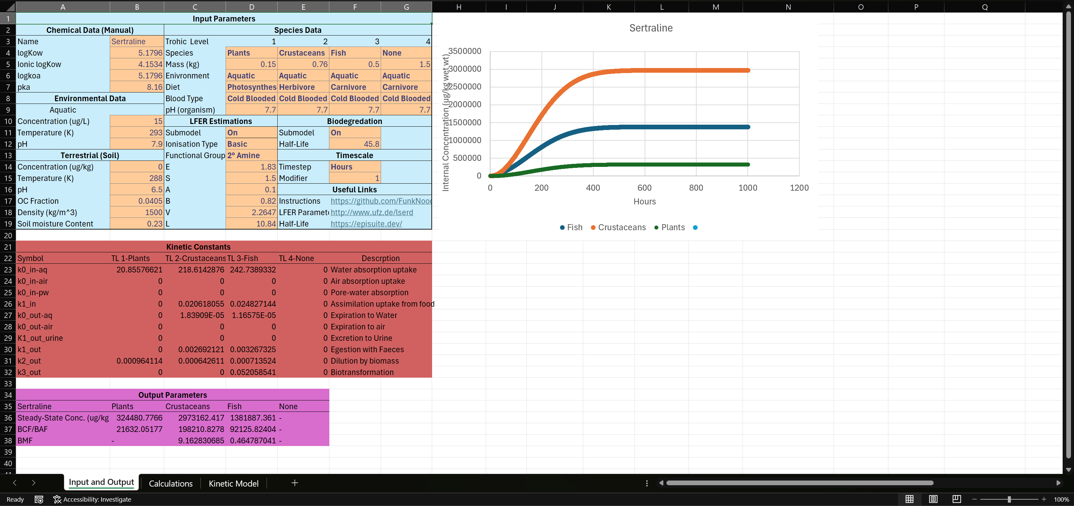
The graph on the input and output page is live, so it will change as the user changes in input data. The useful output data are in the pink block at the bottom. There are a few things to bear in mind when running the model. Firstly, the user should be aiming to get to a steady state for all trophic levels. This means that all of the lines in the graph become level, as seen in the example above. Adjusting the timescale and modifier in the input data can help to get to steady state. Another way to get to steady state is to extend the kinetic model rows, as mentioned in the quick overview. For example:

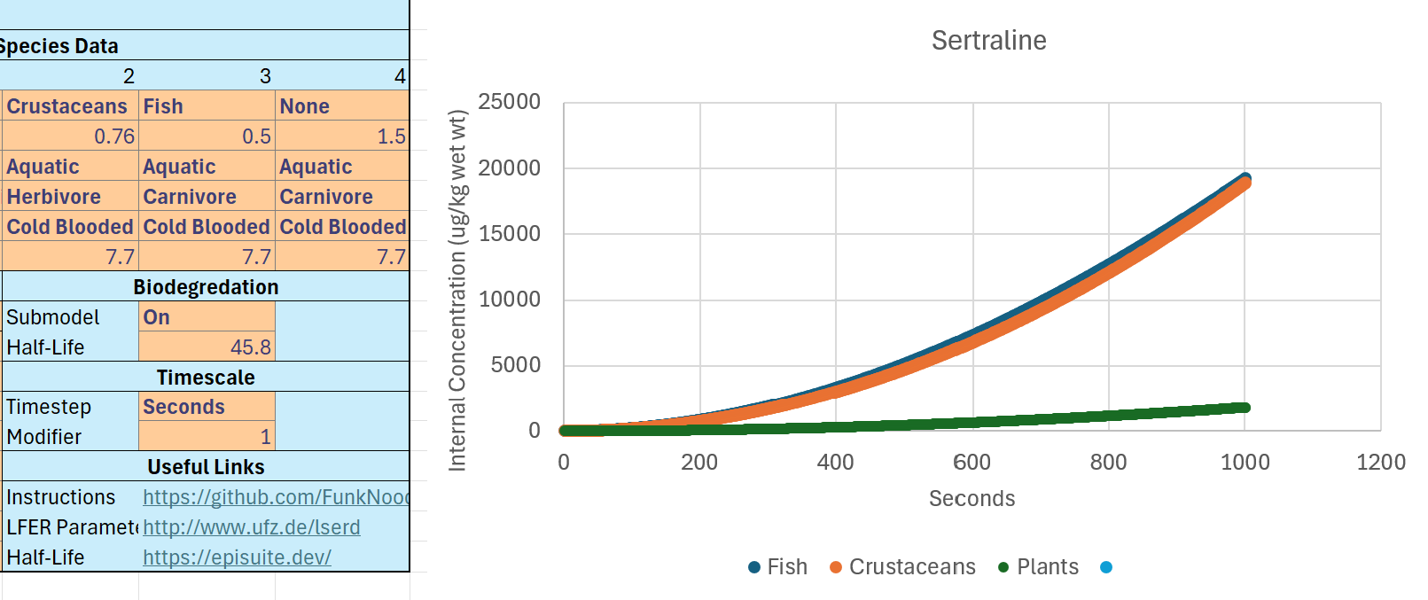
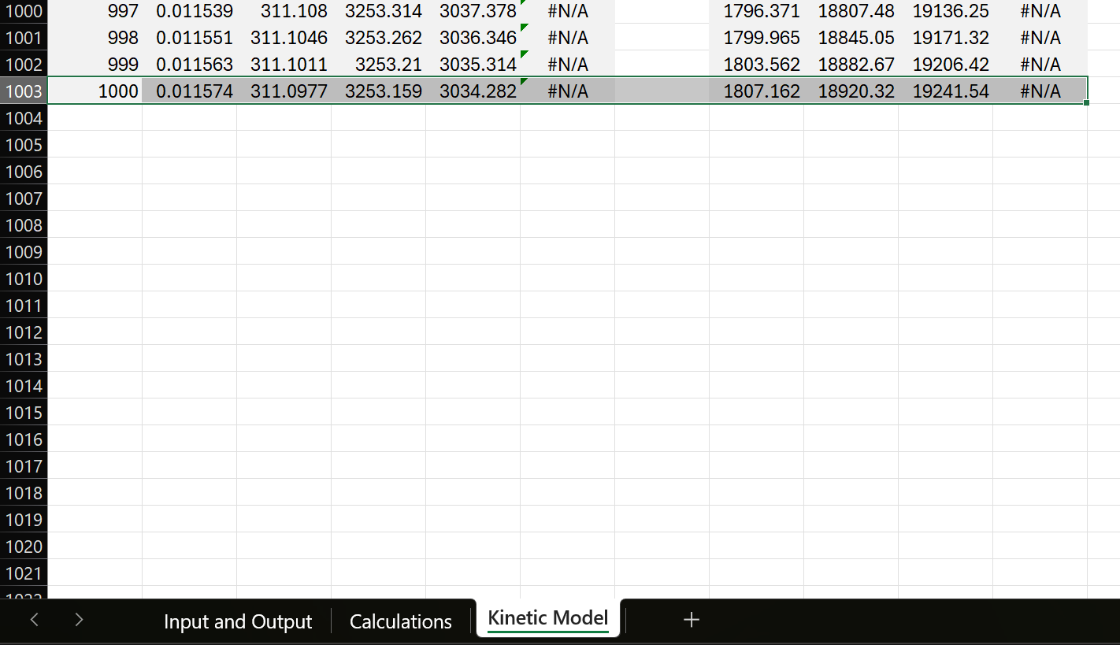

One of the main issues that the user experience are “oscillation errors”. These can occur when the change in concentration is too large for the timestep, which introduces a negative into the model and causes each subsequent timestep to flip between positive and negative values of ever-increasing magnitude:
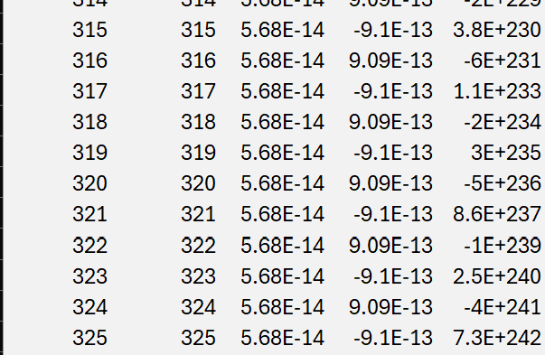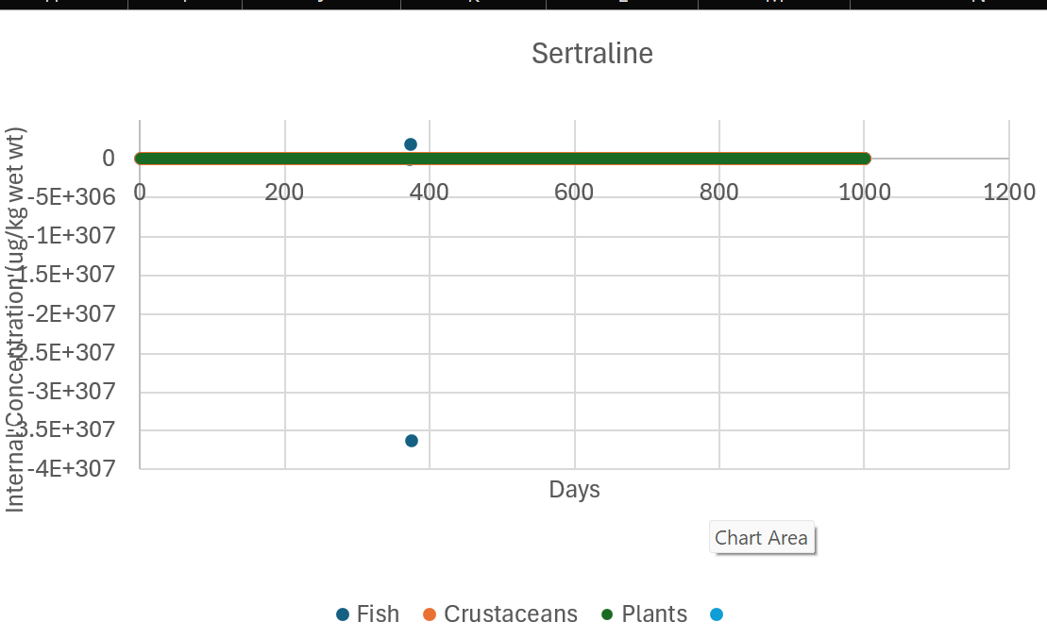

The fix for these is the same as for steady state: change the timscale (e.g. hours to minuites or seconds), increase the modifier, and extend the model if you still do not have steady state. It might take some playing around, especially if the biodegredation sub-model is turned on.

